# Mt Hay, Blue Mountains NSW, Change Detection 2019-2023 Report

Prepared by [Michael Dear](https://mjdear68.github.io/portfolio/), April 2024

## Glossary

Mean: the average of a set of numbers.

Normalised Difference Vegetation Index (NDVI): The NDVI is a common remote sensing index used for the assessment of vegetation cover and vigour. The NDVI has values in the range of -1 to 1. Values below 0 are generally associated with deep water. Values above 0.8 are associated with dense forest.

Masked: Pixels that were excluded from the dataset due to a lack of data e.g. cloud cover

RGB: Red, green, and blue wavelength bands.

NIR: Near infrared wavelength band. The NIR and red bands are combined to create the NDVI.

## Objective

To quantify the changes in land cover at Mt Hay, Blue Mountains NSW following the major bushfire in December 2019.

## Key Points

* The area of sparse vegetation increased from 9.2 ha in 2019 to approximately 46 ha in 2023 within the study area.
* High-density vegetation decreased from 29.5 ha in 2019 to 22.4 ha in 2023.

## Method

Sentinel 2 satellite data was obtained from [Digital Earth Australia's](https://www.dea.ga.gov.au/) Open Data Cube for two dates in each of November 2019 and November 2024. Each plot in the study area was represented by one pixel in the dataset. The two dates for each year were averaged to form RGB, NIR and NDVI datasets. True-colour (RGB) and NDVI images of the study area and its surrounds were plotted and reviewed. A land cover classification was developed using NDVI thresholds, from which class change matrices and a class change map were produced. The NDVI thresholds and class descriptions are contained in Table 1.

Table 1   
NDVI thresholds and descriptions

|  |  |  |  |
| --- | --- | --- | --- |
| **Class Number** | **Class Name** | **Class Description** | **Threshold** |
| 1 | Water | Deep water bodies e.g. lakes, rivers |  |
| 2 | Bare | Bare ground |  |
| 3 | Sparse | Sparse vegetation e.g. scattered shrubs, patchy grass |  |
| 4 | Medium-density | Medium-density vegetation e.g. woodland; post-fire regrowth |  |
| 5 | High-density | Dense vegetation e.g. forest |  |
| 6 | Masked | No data | NaN |

## Plots

### True-colour (RGB) Plots

Figure 1 contains a true-colour representation of the study area and its surrounds. The study area boundary is shown in blue. Mt Hay is in the centre of the images. The 2023 image suggests an increase in bare ground when compared with the 2019 image. The Grose River in the top-left of the image also appears to be less vegetated in 2023, although the river was not included in the study area.

Figure 1   
True-colour (RGB) plots.

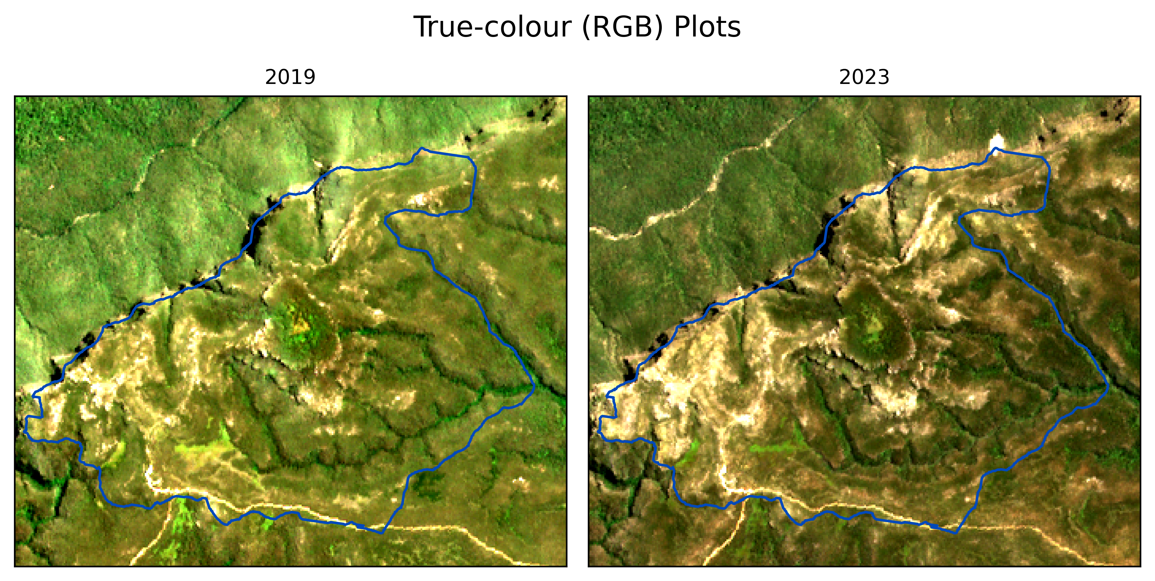

### Normalised Difference Vegetation Index (NDVI)

The NDVI plots (Figure 2) indicate the regions of higher and lower 'greenness' for each period. The increase in orange-red areas in 2023 reflects lower vegetation cover. The red dot in the top-right of the image is bare ground, possibly the result of a landslip that occurred after 2019.

Figure 2   
NDVI plots.

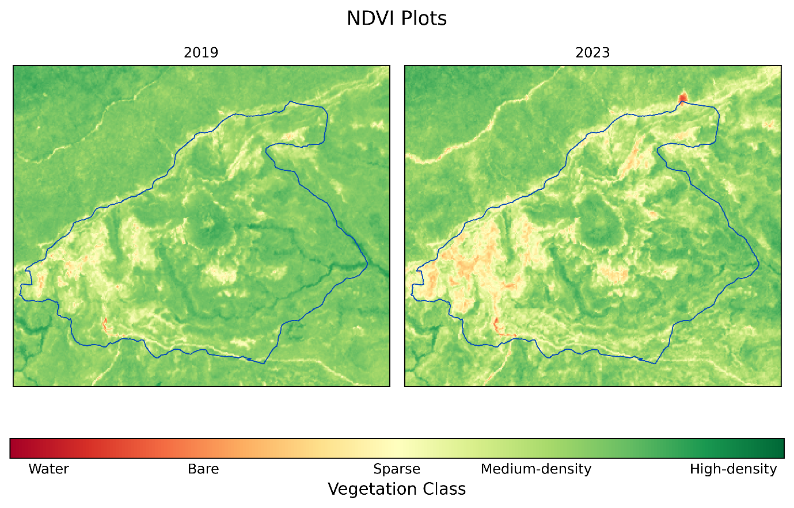

## Normalised Difference Vegetation Index (NDVI) Classification

The NDVI Classification plots (Figure 3) describe the spatial distribution of the landcover classes listed in Table 1. There is an apparent increase in the Sparse class in the south-west of the study area and a decrease in the High-density class scattered through the centre of the study area.

Figure 3   
NDVI Classification plots.

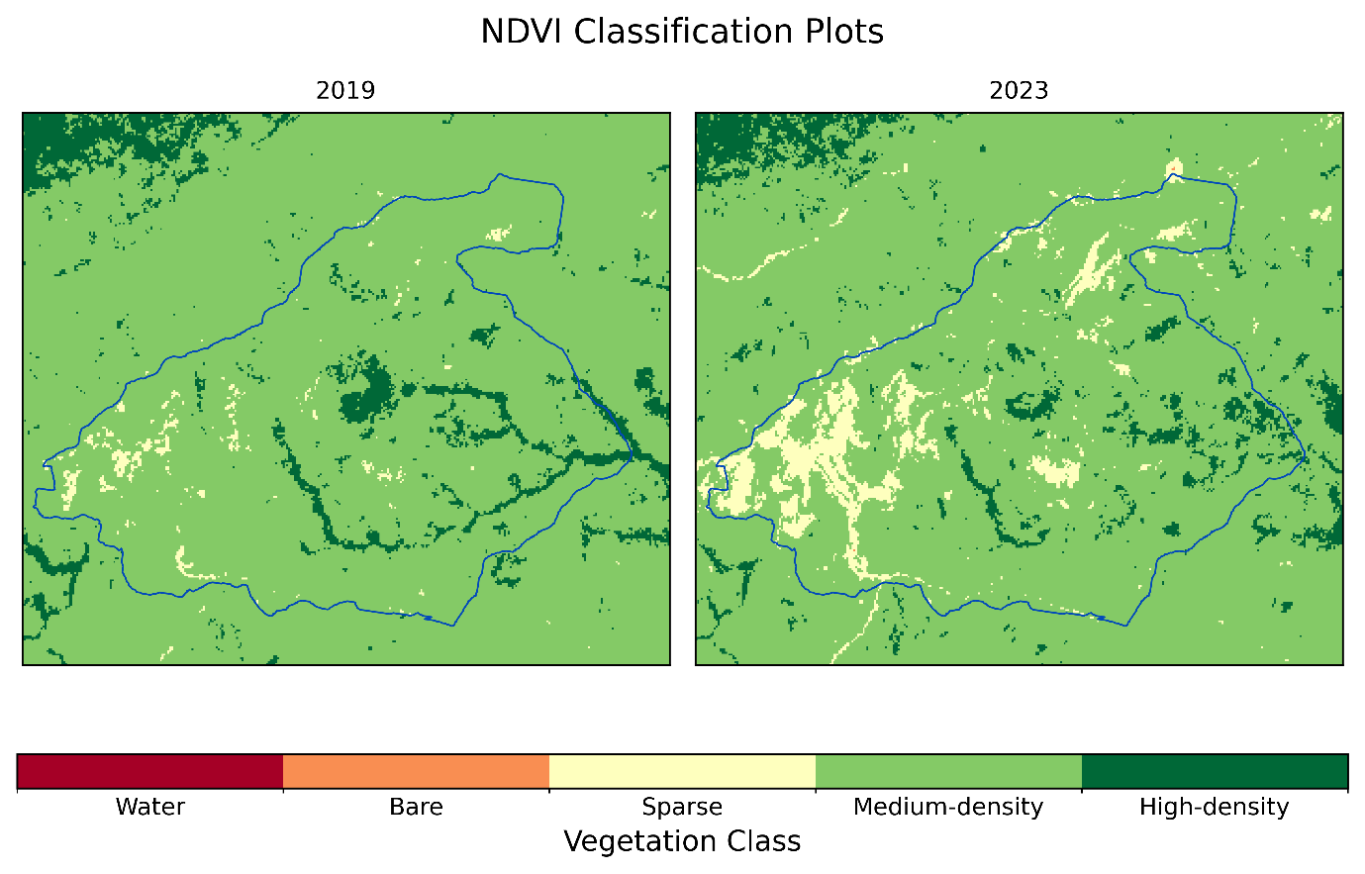

Table 2 displays the percentage of each land cover class in the study area for the given years. Most of the vegetation belongs to the Medium-density class. The major changes occurred in the Sparse and Medium-density classes where the proportion of the Sparse class increased (2.1% to 10.5%), and the Medium-density class decreased (91.2% to 84.5%) from 2019 to 2023. The High-density class also decreased during the study period (6.7% to 5.1%).

Table 2   
Percentage of the study area in each class.

|  |  |  |  |  |  |  |  |
| --- | --- | --- | --- | --- | --- | --- | --- |
|  | **Water** | **Bare** | **Sparse** | **Medium Density** | **High Density** | **Masked** | **Total** |
| **2023** | 0.0 | 0.0 | 10.5 | 84.5 | 5.1 | 0.0 | 100.0 |
| **2019** | 0.0 | 0.0 | 2.1 | 91.2 | 6.7 | 0.0 | 100.0 |

Table 3 indicates that there was an almost 400% increase in the area classified as Sparse between 2019 and 2023. The absolute change was approximately 37 ha. The High-density class decreased by approximately 7 ha, or 24% of the 2019 area.

Table 3   
Annual class differences (hectares, ha)

|  |  |  |  |  |
| --- | --- | --- | --- | --- |
|  | **2023** | **2019** | **2023-2019** | **Change_%** |
| **Water** | 0.00 | 0.00 | 0.00 | NaN |
| **Bare** | 0.01 | 0.00 | 0.01 | inf |
| **Sparse** | 45.97 | 9.23 | 36.74 | 398.0 |
| **Medium-density** | 371.29 | 400.88 | -29.59 | -7.4 |
| **High-density** | 22.36 | 29.52 | -7.16 | -24.3 |
| **Masked** | 0.00 | 0.00 | 0.00 | NaN |

### Class Change

Table 4 displays the area for each class in the later year as a percentage of the total area for each class from the previous year. The rows of the table represent 2019 and the columns represent 2023. Most of the area classified as Sparse in 2019 remained unchanged (98.9%). By contrast, 9.2% of the 2019 Medium-density class was classified as Sparse in 2023. In percentage terms, the largest shift during the study period was in the High-density class of which only 39.3% was still classified as High-density in 2023. The remainder (60.7%) was classified as Medium-density in 2023.

Table 4   
Class change percentages.

|  |  |  |  |  |  |  |  |
| --- | --- | --- | --- | --- | --- | --- | --- |
|  |  | **2023** | | | | | |
|  |  | **Water** | **Bare** | **Sparse** | **Medium-density** | **High-density** | **Masked** |
| **2019** | **Water** | NaN | NaN | NaN | NaN | NaN | NaN |
| **Bare** | NaN | NaN | NaN | NaN | NaN | NaN |
| **Sparse** | 0.0 | 0.1 | 98.9 | 1.0 | 0.0 | 0.0 |
| **Medium-density** | 0.0 | 0.0 | 9.2 | 88.1 | 2.7 | 0.0 |
| **High-density** | 0.0 | 0.0 | 0.0 | 60.7 | 39.3 | 0.0 |
| **Masked** | NaN | NaN | NaN | NaN | NaN | NaN |

The Class Change Map (Figure 4) indicates that the major area for conversion of Medium-density to Sparse occurred in the south-west of the study area, with smaller areas of change in the north-east and to the south of the centre of the study area. Change from High-density to Medium occurred in the centre of the study area around Mt Hay, and along the gullies to the east and south of Mt Hay. The change from Medium-density to High-density was scattered in the eastern part of the study area.

Figure 4   
Class change map with overlay on the 2019 true-colour image.

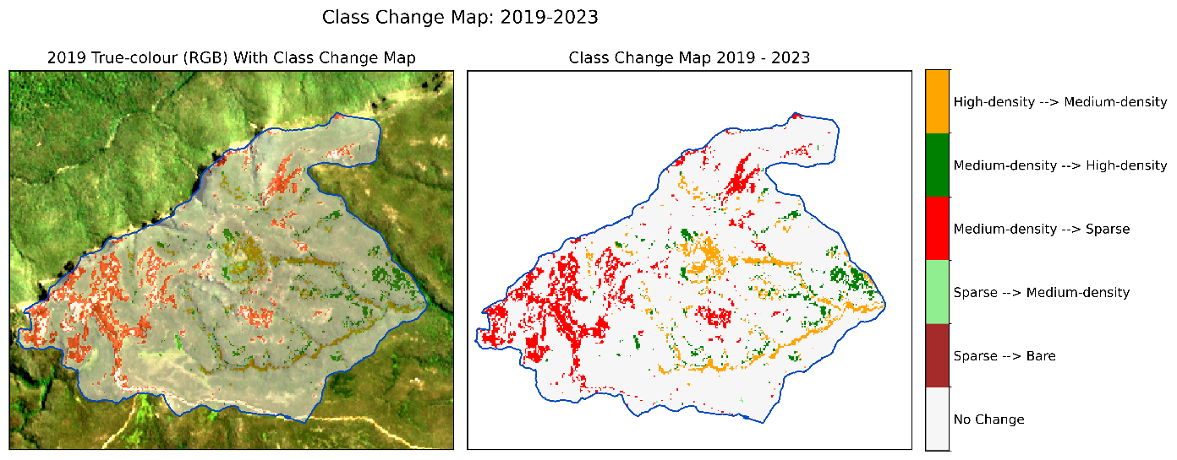

### Limitations

The NDVI thresholds used in the classification were based on literature review and the classification has not been formally assessed for accuracy. Further, the study consisted of a single period and did not account for the effects of seasonality or variations in climate. These limitations should be considered when interpreting the results of this study.